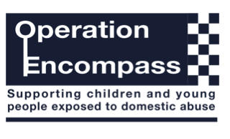

Dear Parent/Carer,

The school has been given the opportunity to take part in a project that will run jointly between schools/ childcare providers and West Midlands Police.

Operation Encompass is the reporting to schools and childcare providers, prior to the start of the next school day, of when a child or young person has been exposed to, or involved in, any domestic incident.

Operation Encompass will ensure that the Designated Safeguarding Lead, known as a Key Adult, is aware and trained to liaise with the local authority to use the information that has been shared, in confidence. The Designated Safeguarding lead will be able to make provision for possible difficulties experienced by children, or their families, who have been involved in, or exposed to, a domestic abuse incident.

We are keen to offer the best support possible to all our children and we believe this will be extremely beneficial for all those involved.

Signed

Mrs B. Carter

